**RENDERVERSE**

**(WEB APPLICATION)**

A MINI-PROJECT REPORT

*Submitted by*

P ABHIGNYA 221701002 ________________ABINAUV R 221701003

*in partial fulfilment for the course*

# CD19651 Mini Project

*for the degree of*

**BACHELOR OF ENGINEERING**

**in**

**COMPUTER SCIENCE AND DESIGN**

RAJALAKSHMI ENGINEERING COLLEGE

RAJALAKSHMI NAGAR

THANDALAM

CHENNAI - 602 105

APRIL 2025

**RAJALAKSHMI ENGINEERING COLLEGE CHENNAI – 602105**

**BONAFIDE CERTIFICATE**

Certified that this project report **“RENDERVERSE_(WEB APPLICATION-EDUCATION PLATFORM)”** is the bonafide work of

**“P ABHIGNYA (221701002), ABINAUV R (221701003)”** who carried out the project work for the subject CD19651 – Mini Project under my supervision.

|  |  |
| --- | --- |
| **SIGNATURE**  **Prof. Uma Maheshwar Rao**  **Head of the Department**  Professor and Head  Computer Science and Design  Rajalakshmi Engineering College  Chennai - 602105 | **SIGNATURE**  **Mr. S. Pradeep Kumar**  **Supervisor**  Assistant Professor  Computer Science and Design  Rajalakshmi Engineering College  Chennai - 602105 |

Submitted to Project and Viva Voce Examination for the subject CD19651 – Mini Project held on .

Internal Examiner External Examiner

**ABSTRACT**

This report outlines the development of an innovative animation teaching application designed to guide users through the entire learning process, from basic sketching to advanced animation techniques. The app employs a modular approach that integrates step-by-step tutorials, simple language transcripts, and engaging assignments to enhance user interaction and understanding. By incorporating interactive elements, progress tracking, and community features, the application aims to create a comprehensive and accessible learning experience for aspiring animators, catering to learners at all levels of expertise. The app's design emphasizes accessibility, engagement, and continuous improvement, with features such as gamification, regular updates, and support for users with disabilities. The educational approach is informed by studies demonstrating the effectiveness of interactive, modular learning and the motivational impact of gamification on learner retention. Through project-based learning and community interaction, the app fosters both individual growth and collaborative learning, ultimately aiming to streamline the process of mastering animation techniques while making it enjoyable and approachable for all users.

**ACKNOWLEDGEMENT**

Initially we thank the Almighty for being with us through every walk of our life and showering his blessings through the endeavor to put forth this report. Our sincere thanks to our Chairman **Mr. S. Meganathan, B.E, F.I.E.,** our Vice Chairman **Mr. Abhay Shankar Meganathan, B.E., M.S.,** and our respected Chairperson **Dr. (Mrs.) Thangam Meganathan, Ph.D.,** for providing us with the requisite infrastructure and sincere endeavoring in educating us in their premier institution.

Our sincere thanks to **Dr. S. N. Murugesan, M.E., Ph.D.,** our beloved Principal for his kind support and facilities provided to complete our work in time. We express our sincere thanks to our **Prof. Uma Maheshwar Rao** Associate Professor and Head of the Department of Computer Science and Design for his guidance and encouragement throughout the project work. We convey our sincere thanks to our internal guide and Project Coordinator, **Mr. S. Pradeep Kumar** Department of Computer Science and Design, Rajalakshmi Engineering College for his valuable guidance throughout the course of the project.

P ABHIGNYA (221701002) ABINAUV R (221701003)

**TABLE OF CONTENTS**

|  |  |  |
| --- | --- | --- |
| **S.NO** | **TITLE** | **PAGE.NO** |
| 1 | Introduction | 7 |
| 2 | Literature Review | 8 |
| 3 | Software Used | 10 |
| 4 | Present Technology | 13 |
| 5 | Proposed Design | 18 |
| 6 | Output | 25 |
| 7 | Conclusion | 29 |

**LIST OF FIGURES**

|  |  |  |
| --- | --- | --- |
| **S.NO** | **TITLE** | **PAGE.NO** |
| 1 | Figma  User Interface | 12 |
| 2 | Login Page | 25 |
| 3 | Home Page | 26 |
| 4 | Animation  Lesson Page | 27 |

**CHAPTER 1 INTRODUCTION**

The animation industry is rapidly evolving, with an increasing demand for skilled animators across various sectors such as film, television, gaming, and digital media. However, learning animation can often be overwhelming due to its technical complexity and the steep learning curve involved. The availability of digital tools and online learning platforms has made it easier for aspiring animators to access educational resources, but many still struggle with fragmented and overwhelming content. The primary aim of this project was to develop a comprehensive and user-friendly animation teaching application that simplifies the learning process and makes animation accessible to a wider audience. By adopting a modular, user-centered design approach, this project sought to address key challenges such as engaging content, user interaction, accessibility, and motivation.

The design process began with extensive user research, including surveys, interviews, and feedback from aspiring animators, to understand their pain points and learning preferences. Insights from this research were then used to guide the creation of an intuitive, interactive platform. The app was designed to cater to learners at various skill levels, from beginners to advanced users, incorporating step-by-step tutorials, quizzes, progress tracking, and community-driven features. This paper outlines the development process of the animation teaching app, focusing on the methodologies employed for user research, content development, and the iterative design process. The ultimate goal was to create an engaging, accessible, and effective learn0ing experience for all users.

**CHAPTER 2**

**LITERATURE REVIEW**

**1. UI/UX Analysis & Design for Mobile Animation Learning Application Prototype (Published in: 2023 International Conference on Digital Education_and_Technology)**As more people seek accessible ways to learn animation, this study focuses on designing a mobile app to teach animation using a user-centered approach. The design process involves understanding users' needs through surveys and interviews, creating prototypes, and testing them with users. The app is aimed at making complex animation concepts easier to learn and more engaging. User testing showed that 85% of users accepted the app, and the final usability score was 82.3, indicating a positive user experience.

**2. UI/UX Design of Interactive Educational Platforms for Animation Learning_(2024-05-18)**This research explores the design of educational platforms for learning animation, focusing on UI/UX principles. It examines existing guidelines for designing user-friendly interfaces in educational apps and looks at how to improve user experience, especially for creative skills like animation. The study highlights design strategies to make the platform easier to use, more engaging, and visually appealing. It also reviews key features like easy navigation and feedback systems to ensure the platform is both educational and motivating for learners.

**3. UI/UX Design for Mobile Learning Platforms in Creative Industries (Published in: 2021 International Journal of Digital Learning)**This study focuses on the design of mobile learning platforms for creative skills, including animation, with an emphasis on UI/UX best practices. The research examines how the design of these platforms can support effective learning by making content accessible and engaging. Key findings suggest that simplicity in navigation, interactive elements, and personalized learning experiences is essential for keeping users motivated. The study also shows that a well-structured, intuitive interface can significantly enhance the learning process and user satisfaction.

**4. Improving User Experience in Educational Apps for Animation: A UI/UX Approach (Published in: 2020 International Conference on Educational_Technology)**This research investigates how to improve the user experience in educational apps focused on animation through effective UI/UX design. By analysing existing animation apps, the study identifies common usability issues such as complex navigation and overwhelming content. It proposes design solutions such as clear visual hierarchies, interactive features, and customizable learning paths to make the learning process more engaging and user-friendly. The results emphasize the importance of a balanced design that caters to both beginner and advanced learners, enhancing overall user satisfaction and learning outcomes.

**CHAPTER 3**

**SOFTWARE USED - FIGMA, REACT.JS, FIREBASE**

We selected Figma for its real-time collaboration and robust UI/UX design tools, ensuring a consistent and visually appealing interface. React.js was used for the front-end development, providing smooth and interactive user experiences. Firebase served as the backend, handling database management and authentication, allowing for seamless data storage and retrieval. VS Code was our primary code editor, enabling efficient development and debugging.

**TOOL SELECTION**

**3.1. Figma for UI/UX Design**

Figma played a crucial role in designing the animation learning platform. Its collaborative features allowed our team to work together in real time, ensuring efficient communication and rapid iterations. The vector tools helped create high-quality, scalable design elements, while the component system-maintained consistency across the platform. The responsive design approach ensured the platform adapted well to different devices, enhancing the overall user experience.

**3.2. React.js for Front-End Development**

React.js was chosen for its efficiency in building dynamic and interactive user interfaces. Its component-based structure allowed for modular development, making it easier to manage and scale the application. The virtual DOM in React ensured smooth rendering and responsive interactions, providing an engaging learning experience. State management and routing were handled using React's built-in features, keeping the front-end lightweight and optimized.

**3.3. Firebase for Backend and Authentication**

For the backend, Firebase was used to manage the database and authentication processes. Firebase Firestore stored user data, learning progress, and course details in a structured, scalable manner. Firebase Authentication provided a secure and efficient login system without the need for third-party authentication services. This ensured user data remained secure while simplifying account management. Cloud functions were not utilized in this project, keeping the backend lightweight.

**3.4. VS Code for Development**

VS Code was our primary development environment due to its lightweight design and extensive features. We used it for writing, debugging, and managing the codebase.

**3.5. Design Implementation with Figma**

Using Figma, we followed a structured design process focused on improving UI/UX. The vector tools helped in creating sharp, scalable design assets, while the component system ensured consistency throughout the platform. Prototyping features allowed us to simulate interactions and test usability before development, ensuring a seamless user experience. The responsive design approach made sure that the platform functioned optimally on mobile, tablet, and desktop devices.

**3.6. Prototyping and Feedback**

Figma’s prototyping tools enabled us to create interactive mock-ups that simulated real user interactions. This allowed stakeholders to experience the design firsthand and provide immediate feedback. The iterative process helped refine the interface. Direct commenting and collaborative editing within Figma streamlined the review and revision process, minimizing delays in development.

**3.7. Collaboration and Real-Time Updates**

Figma’s cloud-based collaboration features were crucial for our remote team, allowing real-time design updates and discussions without lengthy email exchanges. This ensured that everyone had access to the latest design versions, reducing inconsistencies and improving efficiency. The ability to work simultaneously on different sections of the project accelerated the development process and kept the team aligned.

**3.8. App Development with React.js and Firebase**

The development phase was powered by React.js for the front-end and Firebase for backend services. React’s modular architecture allowed us to build reusable components, reducing redundancy and ensuring a structured codebase. Firebase Firestore managed user data efficiently, providing real-time updates for learning progress and course materials. Authentication was implemented using Firebase Authentication, ensuring a secure and streamlined user login experience.

**3.9. Outcome and Impact**

The combination of Figma, React.js, and Firebase resulted in a highly responsive and scalable animation learning platform. Post-launch user feedback indicated a significant improvement in engagement, with users praising the intuitive design and seamless performance. The project successfully met its goal of delivering a smooth and interactive learning experience, proving that a well-structured UI/UX, combined with an optimized tech stack, can enhance digital education effectively.

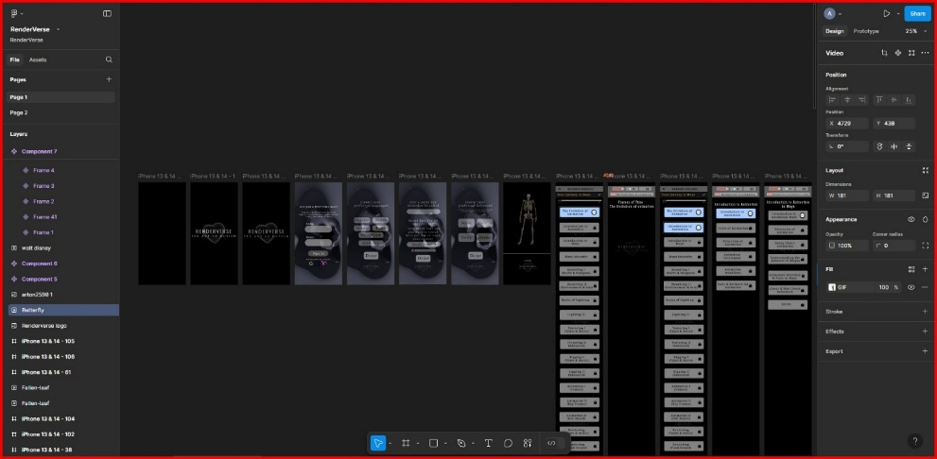

Fig 1: The user interface of the “FIGMA” software.

**CHAPTER 4 PRESENT TECHNLOGY**

# The animation learning platform integrates modern tools and frameworks to provide an engaging, efficient, and scalable learning experience. This section outlines the software architecture, data handling, user interface design, and security measures used in the platform.

# 4.1. Software Architecture

# The platform is designed with a modern, scalable architecture that supports dynamic learning content and a growing user base. The core components include:

# Front_End_(React.js) The user interface is built using React.js, a powerful JavaScript library known for its modular, component-based structure. This ensures smooth, interactive user experiences across different devices. The platform follows responsive design principles, allowing seamless adaptation to mobile, tablet, and desktop screens.

# Back_End_(Firebase_Firestore) The platform does not rely on traditional backend frameworks like Node.js or Express. Instead, Firebase Firestore is used as a serverless backend, handling real-time data storage and retrieval. Firestore enables automatic synchronization of user progress and course data, ensuring learners always have up-to-date information.

# Authentication_(Firebase_Authentication) Firebase Authentication provides a secure, scalable login system, allowing users to sign in via email, Google, or other authentication providers. This eliminates the need for third-party authentication services while maintaining security and ease of access.

# Database_(Firebase_Firestore) Instead of relational databases like PostgreSQL or MySQL, the platform uses Firebase Firestore, a NoSQL cloud database optimized for scalability and real-time updates. It efficiently stores user data, course progress, quizzes, and project submissions while ensuring rapid data access.

# 4.2. User Interface and Experience (UI/UX)

# The platform is designed to be intuitive, engaging, and user-friendly, incorporating key UI/UX principles to enhance learning:

# Responsive_Design The interface automatically adjusts to different devices, ensuring a seamless experience across smartphones, tablets, and desktops.

# Interactive_Learning_Elements The platform integrates animations, quizzes, and project-based tasks to create an engaging, hands-on learning experience.

# Accessibility_Features While basic accessibility features such as adjustable text sizes and screen reader support are implemented, further improvements can be made to enhance usability for learners with disabilities.

# Collaborative_Design_with_Figma The UI/UX was designed using Figma, allowing real-time collaboration and iterative testing. The component-based design system ensured consistency across the platform.

# Security Measures

# Secure_Authentication Firebase Authentication ensures safe and seamless user login without relying on OAuth 2.0 or external authentication providers.

# Data_Encryption All sensitive user data is encrypted during storage and transmission to protect against unauthorized access.

# Privacy_Compliance While the platform does not use third-party tools for security monitoring, it follows industry best practices to ensure user data privacy and secure handling of personal information.

* 1. **Limitations**

Although the animation learning platform utilizes modern technologies to provide an engaging learning experience, several limitations remain that affect its performance, usability, and overall learner satisfaction. Recognizing these limitations is essential for guiding future improvements. Below are some of the primary challenges currently faced by the platform:

* + 1. **User Interface and User Experience (UI/UX)**
       1. **Complex Navigation:** Users often find the platform's navigation challenging, particularly when trying to access different learning modules or find specific tutorials. This can result in a frustrating experience, especially for beginners who may struggle to locate key features.
       2. **Outdated Design:** The platform's design may feel outdated compared to other modern educational platforms. Aesthetic updates, more intuitive layouts, and interactive feedback systems are areas that require significant improvements to align with current design trends and learner expectations.
    2. **Accessibility**
       1. **Limited Accessibility Features:** The platform lacks comprehensive accessibility features such as screen reader support, voice commands, and high-contrast modes for visually impaired users. This limits accessibility for users with disabilities and excludes a key group of potential learners.
    3. **Content Personalization and Progress Tracking**
       1. **Limited Personalization:** The platform currently offers minimal personalization options, such as content recommendations based on user behavior or preferences. A more tailored learning experience is essential to keep learners engaged and motivated, similar to what is found in leading educational apps.
       2. **Inadequate Progress Tracking:** While there is basic progress tracking, it could be enhanced with more detailed metrics and insights to help learners understand their strengths, weaknesses, and overall progress through the course materials.
    4. **Integration with Other Learning Tools**
       1. **Poor Integration with External Tools:** The platform lacks integration with other creative tools or software commonly used by animators, such as digital drawing apps or animation software. This makes it harder for users to seamlessly apply what they've learned in real-world projects.
       2. **Limited Community Features:** The platform’s community features, like sharing work or receiving feedback, are underdeveloped. Encouraging user interaction and fostering a community where learners can collaborate and share ideas could greatly enhance the learning experience.

**CHAPTER 5**

**PROPOSED DESIGN**

The proposed animation learning application is designed to provide an interactive and engaging learning experience for users of all skill levels. The application will integrate modular learning techniques, interactive exercises, and community features to ensure a comprehensive and accessible learning environment.

**5.1. Key Features**

**5.1.1. Modular Learning Approach**

* Courses structured into step-by-step modules, ranging from basic sketching to advanced animation techniques.
* Each module includes tutorials, practical exercises, and assessments to reinforce learning.
* Users can progress at their own pace and revisit previous lessons as needed.

**5.1.2. Interactive Learning Elements**

* Quizzes, drag-and-drop activities, and real-time animation practice tools.
* Clickable hotspots for exploring animation concepts interactively.
* AI-powered feedback on drawing and animation exercises.

**5.1.3. Progress Tracking & Gamification**

* Users can track their progress with a personalized dashboard.
* Gamification elements like badges, levels, and leaderboards encourage motivation.
* Users receive rewards for completing modules and engaging with the community.

**5.1.4. Community and Collaboration**

* Discussion forums for users to ask questions, share work, and receive feedback.
* Peer review system to allow learners to critique and improve each other’s animations.
* Live chat sessions and webinars with professional animators.

**5.1.5. Accessibility & Inclusivity**

* Adjustable text sizes and color contrast options for improved visibility.
* Screen reader compatibility and voice commands for navigation.
* Subtitled video tutorials and transcripts for hearing-impaired users.

**5.1.6. Mobile-Friendly & Cross-Platform Compatibility**

* Optimized for smartphones, tablets, and desktops.
* Cloud synchronization allows users to switch devices without losing progress.
* Offline mode for downloading lessons and practicing without an internet connection.

**5.1.7. Integration with Animation Tools**

* Compatibility with popular animation software such as Adobe Animate, Blender, and Toon Boom.
* Direct export and import features for seamless workflow between the app and professional tools.
* In-app mini-projects that can be enhanced using external animation software.

**5.1.8. Personalized Learning Experience**

* AI-driven recommendations for courses based on user progress and preferences.
* Customizable learning paths tailored to different animation styles (e.g., 2D, 3D, stop-motion).
* Option to set personal learning goals and receive reminders.

**5.1.9. Regular Updates & Support**

* Frequent content updates with new animation techniques and industry trends.
* Dedicated support section with FAQs, troubleshooting guides, and direct helpdesk access.
* Community-driven feedback system for continuous improvement.

**5.1.10. User Interface Design Considerations**

* **Intuitive Navigation:** Clean and simple UI with clear categorization of courses and features.
* **Minimalistic Design:** Avoids clutter while maintaining engaging visual elements.
* **Dark & Light Modes:** Provides customization for user comfort.
* **Interactive Animations:** Uses micro-interactions for an engaging and immersive experience.

**5.1.11. Security & Privacy Measures**

* Secure login with OAuth authentication.
* Data encryption to protect user information.
* Compliance with data protection regulations (GDPR, CCPA)

**5.1.12. Expected Outcomes**

* Increased user engagement through interactive and gamified learning.
* Enhanced accessibility ensuring inclusivity for diverse learners.
* Seamless learning experience across multiple devices with real-time progress tracking.
* Stronger community-driven learning through collaboration and peer feedback.

**5.2 User Flow Diagram**

**Start**

**↓**

**User Visits Platform**

**↓**

**Sign Up / Log In**

**↓**

**Dashboard**

**↓**

**Choose Course → View Course Details**

**↓**

**Start Learning**

**↓**

**Watch Tutorials**

**↓**

**Complete Assignment**

**↓**

**Take Quiz**

**↓**

**┌──────────────Yes─────────┐**

**↓ ↓**

**Pass? → Unlock Next Module → Track Progress → Earn Badges**

**↓ ↓**

**No Join Community**

**↓ ↓**

**Retry Quiz → Share Work & Discuss → Certificate Upon Completion**

**↓**

**End**

* 1. **Advantages**

# The development of a comprehensive animation learning platform offers several benefits, enhancing user engagement, accessibility, and skill development.

# 5.3.1. Enhanced Learning Experience

# Interactive Learning: The platform integrates interactive elements such as quizzes, drag-and-drop exercises, and real-time feedback, making learning engaging and effective.

# Structured Curriculum: A step-by-step modular learning approach ensures that users progress logically from basic sketching to advanced animation techniques.

# Project-Based Learning: Encourages users to apply their skills through hands-on projects, reinforcing their knowledge and fostering creativity.

# 5.3.2. Accessibility and Inclusivity

# User-Friendly Interface: A well-designed UI/UX makes navigation intuitive, ensuring a seamless learning experience for users at all levels.

# Multilingual Support: Providing courses in multiple languages increases accessibility for a diverse audience.

# Accessibility Features: Features like subtitles, screen reader compatibility, and adjustable text sizes ensure that users with disabilities can effectively engage with the platform.

# 5.3.3. Increased Engagement and Motivation

# Gamification Elements: The use of badges, leaderboards, and progress tracking keeps learners motivated and encourages consistent learning.

# Community Interaction: A built-in forum or chat feature allows users to share their work, ask questions, and receive feedback from peers and mentors.

# Personalized Learning Paths: AI-driven recommendations help users choose courses and exercises tailored to their skill level and interests.

# 5.3.4. Integration and Scalability

# Seamless Integration with Animation Tools: The platform can integrate with popular animation software (e.g., Adobe Animate, Blender) to help users transition smoothly to industry-standard tools.

# Cloud-Based Learning: Users can access their projects and progress from any device, allowing for flexible and convenient learning.

# Scalable Infrastructure: Ensures the platform can handle a growing number of users without performance issues.

# 5.3.5. Competitive Advantage

# Comprehensive Resource Library: Offers downloadable assets, references, and tutorials, making it a one-stop learning hub for aspiring animators.

# Industry-Relevant Skills: Provides training that aligns with industry needs, increasing users' employability and job prospects.

# Continuous Updates: Regularly updated content keeps users informed about the latest trends and advancements in animation.

**CHAPTER 6**

**OUTPUT**

**PROJECT LINK**

<https://www.figma.com/design/m81Ymvk6DVVMS7fiab6GqX/RenderVerse?node-id=0-1&p=f&t=VXI1ZKGSFD6M99PU-0>

**GITHUB LINK**

<https://github.com/abiiiiiiiiiiiiiii/Render_Verse---Mini-Project>

FIGMA TEMPLATE

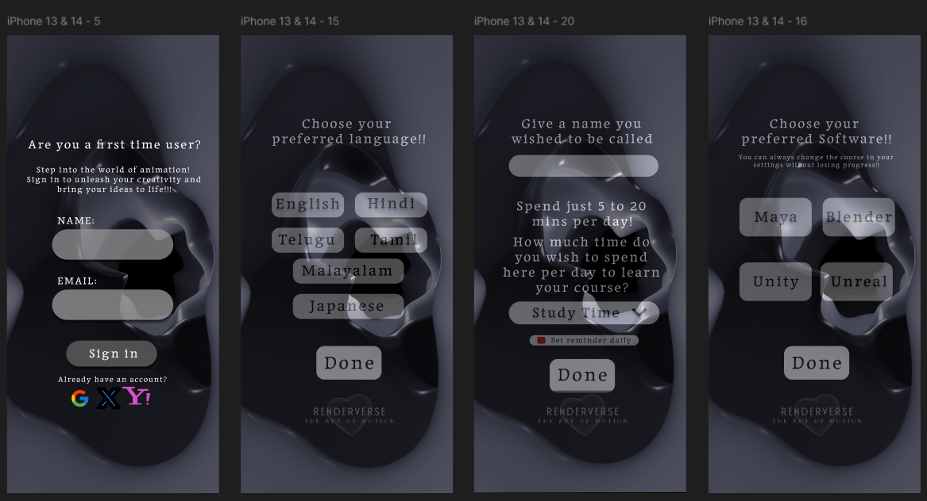

APPLICATION INTERFACE

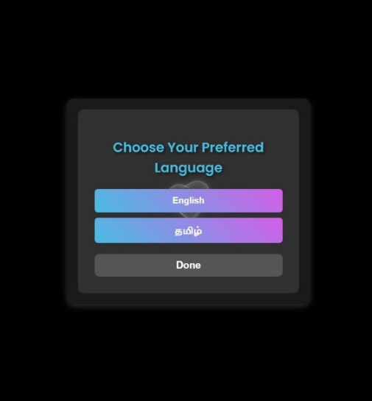 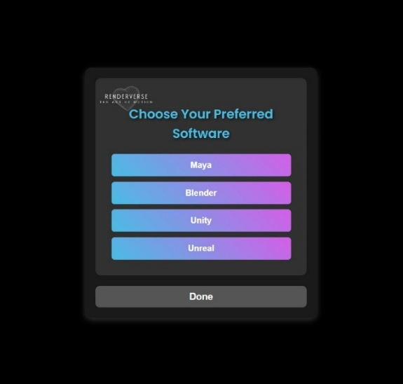 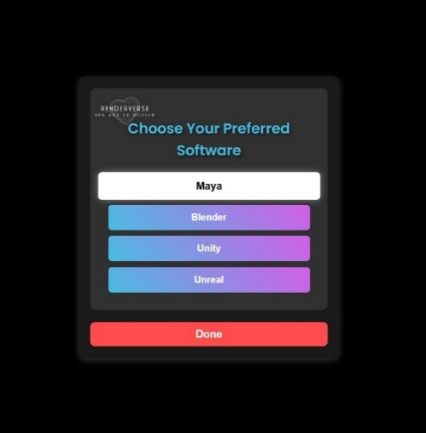

Fig 6.1. Login Page

These pages have the features like sign in using google, multiple languages support, keep me signed in option and login using pin and password.

FIGMA TEMPLATE

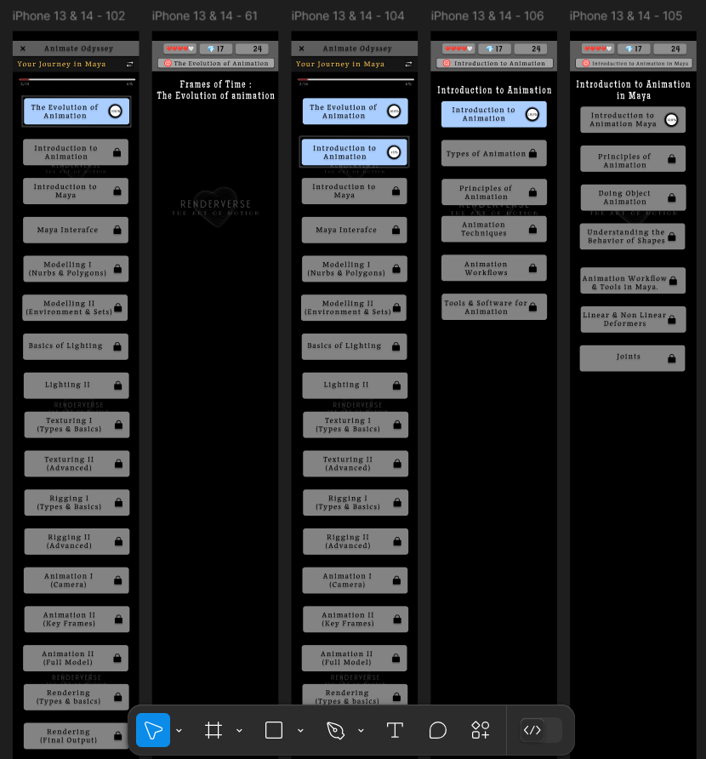

APPLICATION INTERFACE

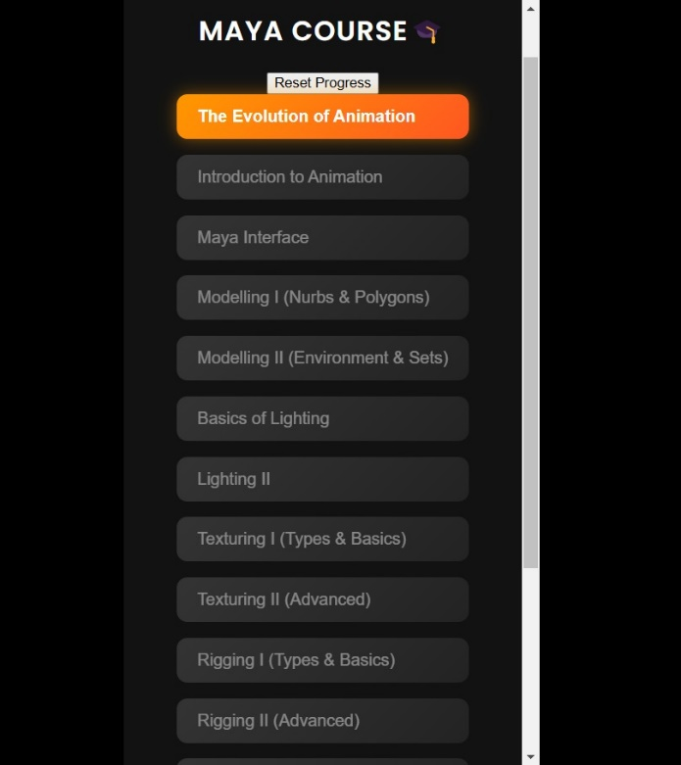

Fig 6.2. Home Page

FIGMA TEMPLATE

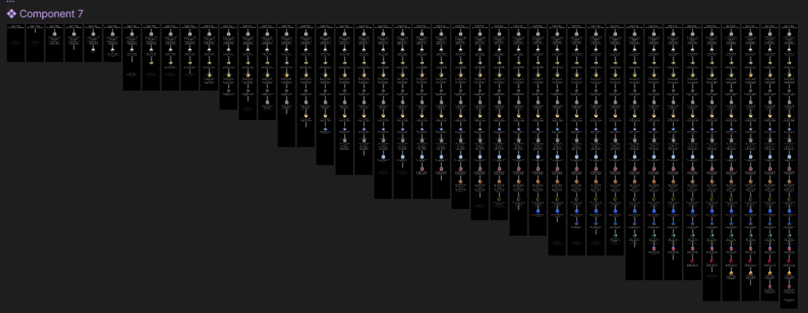

APPLICATION INTERFACE

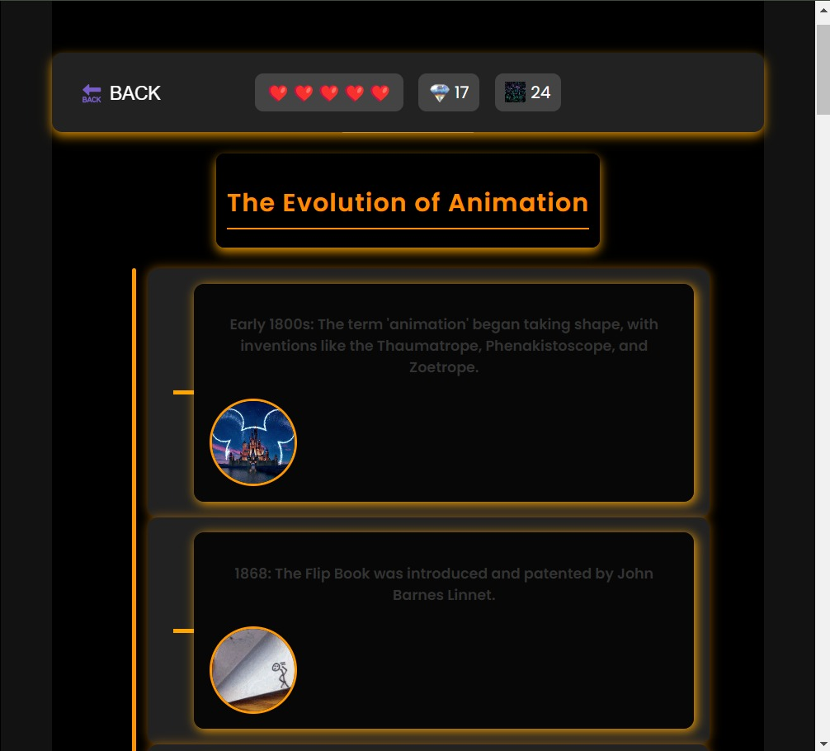

Fig 6.3. Animation Lesson Page

**CHAPTER 7**

**CONCLUSION**

The animation learning platform serves as a vital resource for aspiring animators, offering structured and interactive learning experiences that bridge the gap between traditional education and industry requirements. Despite its current strengths, the platform faces several challenges, including limited accessibility features, outdated UI/UX design, and a lack of personalization and integration with industry-standard tools.

The proposed redesign aims to address these limitations by improving user experience, introducing personalized learning paths, enhancing accessibility, and integrating seamless collaboration features. By incorporating interactive elements, real-time feedback, and a structured curriculum, the platform will provide a more engaging and effective learning environment. Additionally, advanced data analytics and AI-driven recommendations will help learners track their progress and receive tailored content that aligns with their skill level and learning goals.

Beyond improving the user experience, these enhancements will position the platform as a competitive and future-ready learning tool. As the animation industry continues to evolve with new technologies and methodologies, a modernized and scalable platform will ensure that learners are equipped with the necessary skills to excel in the field.

In conclusion, the redesign of the animation learning platform is a strategic step toward making animation education more accessible, engaging, and industry-relevant. By addressing current challenges and embracing technological advancements, the platform will empower learners, enhance their creative potential, and establish itself as a leading resource in the world of digital animation education.

**REFERENCE**

1. Lasseter, J. (1987). Principles of Traditional Animation Applied to 3D Computer Animation. ACM SIGGRAPH Computer Graphics, 21(4), 35-44.
2. Thomas, F., & Johnston, O. (1995). The Illusion of Life: Disney Animation. Hyperion.
3. Williams, R. (2009). The Animator’s Survival Kit: A Manual of Methods, Principles, and Formulas for Classical, Computer, Games, Stop Motion, and Internet Animators. Faber & Faber.
4. Packer, J. (2015). Animate to Educate: Using Animation as a Teaching Tool in Digital Learning Environments. Routledge.
5. Chandler, D. M., & Lee, S. H. (2017). Digital Animation: A Technical Introduction. CRC Press.
6. White, T. (2012). Animation from Pencils to Pixels: Classical Techniques for the Digital Animator. Focal Press.
7. Figma. (n.d.). Figma for UI/UX Design in Animation Learning Platforms. Figma Help Center.
8. Reinman, K., & Chandler, M. (2020). The Role of UX/UI in Digital Learning: A Case Study on Animation-Based Education. UX Design Journal, 10(2), 45-62.
9. Norman, D. A. (2013). The Design of Everyday Things: Revised and Expanded Edition. Basic Books.
10. Krug, S. (2014). Don’t Make Me Think, Revisited: A Common-Sense Approach to Web Usability. New Riders.
11. Tidwell, J. (2010). Designing Interfaces: Patterns for Effective Interaction Design. O'Reilly Media.
12. Saffer, D. (2009). Designing for Interaction: Creating Innovative Applications and Devices. New Riders.
13. Buley, L. (2013). The User Experience Team of One: A Research and Design Survival Guide. Rosenfeld Media.
14. Friedman, V. (Ed.). (2020). Smashing UX Design: Foundations for Designing Online User Experiences. Smashing Magazine.
15. Case Study: Developing Interactive Learning for Animation Education. UX Magazine.